

internship report OF

sean thabo ndlovu

Student number:15932



computer science

TABLE OF CONTENTS:

INITIAL PROCESS…………………………………………………………. 2

1. Round 1………………………………………………………………. 2
2. Round 2………………………………………………………………. 3
   1. Driver installation………………………………………………... 3
   2. Operation system installation……………………………………. 3
   3. Employment……………………………………………………… 3
   4. Equipment and resources………………………………………… 4

Making a profit…………………………………………………………………. .4

1. Round 3……….……………………………………………………...….. 4
   1. Network configuration and router installation………………..…...…4
   2. HR & Employment…………………………………………..……....5
   3. Resources…………………………………………………..………...5
2. Round 4…………………………………………………….….……….....5
   1. Removal of unwanted software………………………….…………..5
   2. Investments and amenities………………………..………………….5
   3. Suppliers…………………………………………..…………………5
3. Round 5…………………………………………………..…………….…6
4. Round 6 & 7..…………………………………………….…………….…6
   1. Marketing…………………………………………….………………6
   2. Supplies and sales……...…………………………….………………6
   3. Equipment……………………………………………………………6
5. Lessons and Observations so far………………………….………………7
   1. Observations………………………………………………………….7
   2. Lessons learnt………………………………………...………………7
6. Round 8……………………………………………………………….…...7
   1. Data corruption and recovery…………………………………………8
   2. Investments and HR…………………………………………………..8
   3. Marketing……………………………………………………………..8
   4. Supplies and sales……………………………………………………..8
7. Round 9……………………………………………………………………9
   1. Creating a website with cms…….…………………………………….9
   2. Investments and employment…………………………………….… 10
   3. Supplies and sales…………………………………………………... 10
8. Round 10 & 11…………………………………………………..………. 10
   1. HR & employment………………………………………..…………10
   2. Investments…………………………………………………….…….11

CONCLUSION…………………………………………………………..………..12

1. Round 12………………………………………………………………….12
2. Accomplishments…………………………………………………………12

INITIAL PROCESS

In this particular internship we were first allocated into groups and each group was in charge of their own IT service company. Our primary task and/or focus was to plan an offer for our company and then equip the company with the appropriate workstations, equipment and resources needed to provide which ever service we are offering to our customers in order to make a profit. Our company is also in competition with other groups as well on the market, meaning to say that any decisions that we made not only affected our company but the other companies on the same market as well.

1. Round 1

The first round of the simulation began on the 15th of October 2020, at the time 16:50:45. At this point we are building and organising our company by assigning roles, buying the necessary things needed to start turning a profit.

We first chose a company name, and continued to making our mission statement. Each person in our group then got assigned roles and we also decided the rules we as employees also needs to follow in order to make our teamwork more efficient. I got the role of being the head of HR department, and so I was tasked with hiring and firing employees as well as making sure the employees are satisfied and well trained in their positions.

We then proceeded to selecting the offers our company has. We selected these offers based on the expected demand that we had to calculate. The calculation was fairly simple, for each offer we were given an annual demand, expected price, service time and seasonality ratio, and so to calculate the expected demand for the service we have to divide the annual demand by 12 in order to get the monthly demand we then multiply it with the seasonality ratio.

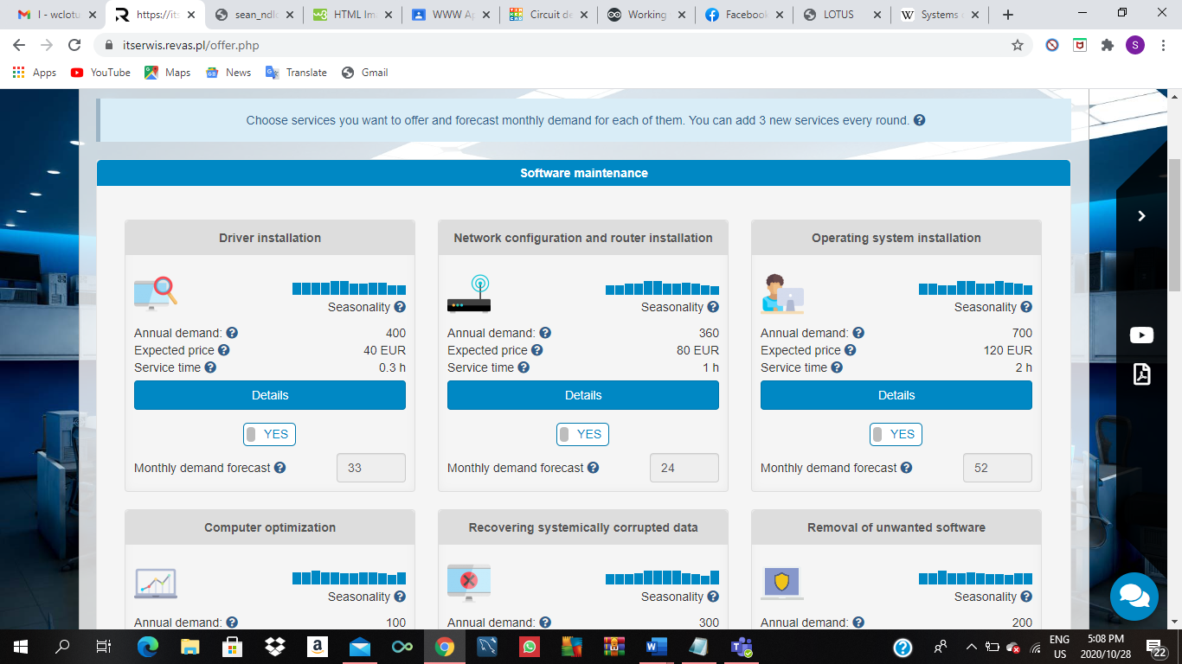 (annual demand/12) *seasonality ratio

Through this we ended up selecting Driver installation, Network configuration and router installation and operation system installation as our first 3 offers.

Every employee needs a workspace and equipment in order for him/her to be able to complete their assigned job and so our next decision was to buy a workstation. We only bought one due to the fact that we only needed one employee to be able to finish the required services. We were able to calculate the number of employees we would need by dividing the number of man hours needed to perform all services (this is the sum of the monthly demand forecast of all services offered by the company) by the employee’s monthly working time. My teammates then proceeded to choosing a bank and an accounting office to keep record of our spending.

1. Round 2

In the second round our task was to now acquire all the required equipment and resources as well as employ a person with the particular skills needed to provide the services offered by the company. Int this round we were introduced to our suppliers and as head of HR I finally employed someone.

In this round we only decided to prepare the Driver installation as well as the Operation system installation services for sale as they were in higher demand that month.

**2.1 Driver installation**

A driver, or device driver, is a software program that enables a specific hardware device to work with a computer's operating system. Drivers may be required for internal components, such as video cards and optical media drives, as well as external ones, such as printers and monitors. However, even if a hardware device is recognized by the operating system, installing the correct drivers may provide additional options and functionality for the device, due to this the demand of people who need this is very high.

This service was beneficial because it only takes 0,3 hours to complete and needed no resources which means less expenses for our company. All this service required was Diagnostic and repair software package as well as an IT specialist in order for it to be sold.

The process of completion for this service was to first simply run a diagnostic test on the device and then using the right software install the driver: manually the IT specialist will just go to the Control Panel and open Device Manager. Find the device that you are trying to install a driver to then right click the device and select properties, select Driver tab, then click the Update Driver button. Choose Browse my computer for driver software. Browse for the .inf driver file. Open and Next and that should complete the process.

**2.2 Operation system installation**

Operation system installation is a similar service to driver installation, the primary difference being that instead of drivers you are focused on the operating systems. The general scope of this service is: Install or Re-install an operating system on one computer, ensure that all necessary drivers have been installed, make sure system is up to date, and finally to verify the system is functioning properly.

No equipment is required for this service, the only disadvantage I saw with this service is that one operating system per customer is required and, in the simulation, the average costs of the operating system were quite high.

**2.3 Employment**

In this round I employed a 30-year-old IT specialist named Clark. He is a junior expert in terms of experience and works 160 hours a month for an average of 3800 salary. He was the only one hired as there was no need for any more people for the amount of services we were providing for this round. He was the ideal candidate due to this and that he has a high percentage of customer satisfaction that I employed him.

**2.4 Equipment and resources**

The equipment bought for our workstation was Diagnostic and repair software package, a Crimper and a cable tester. We then bought 52 operating systems and 24 routers from our suppliers ElectroShop.

Making a profit

On the onset of the simulation each team (company) started with 40000 euros. The goal of our company by the end of the fiscal year was to have more than our initial amount of money in our account balance. Although at this current moment in time our company was 12 000 below initial, I was beginning to grasp the small business and the operating process of an IT company. I had noticed that our fault was buying resources we had not needed or more than what was required at that specific month.

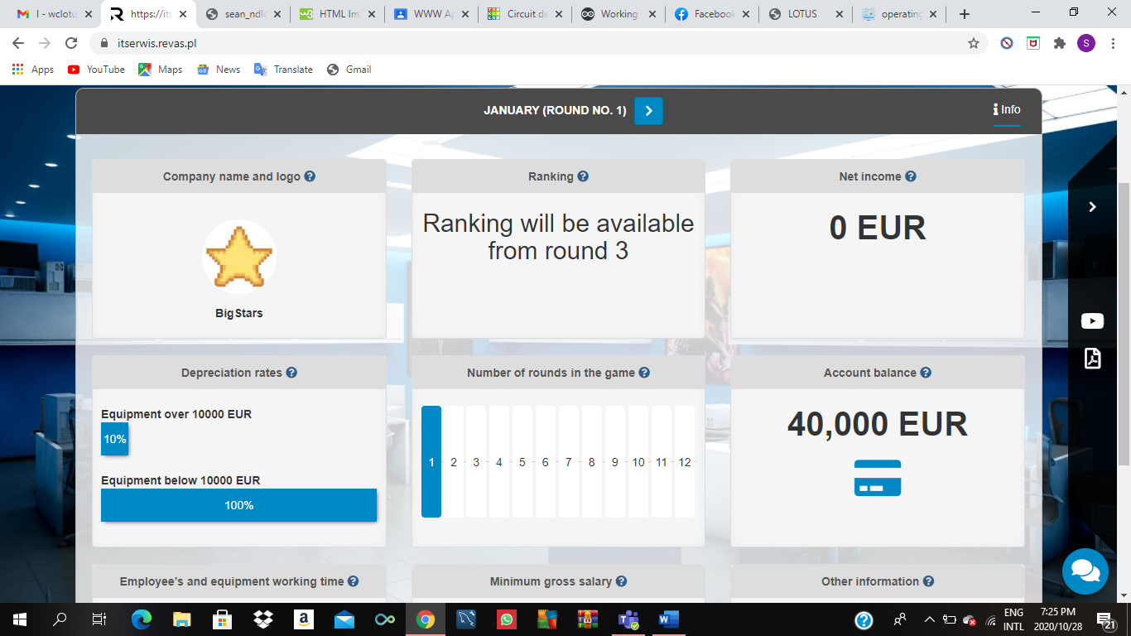 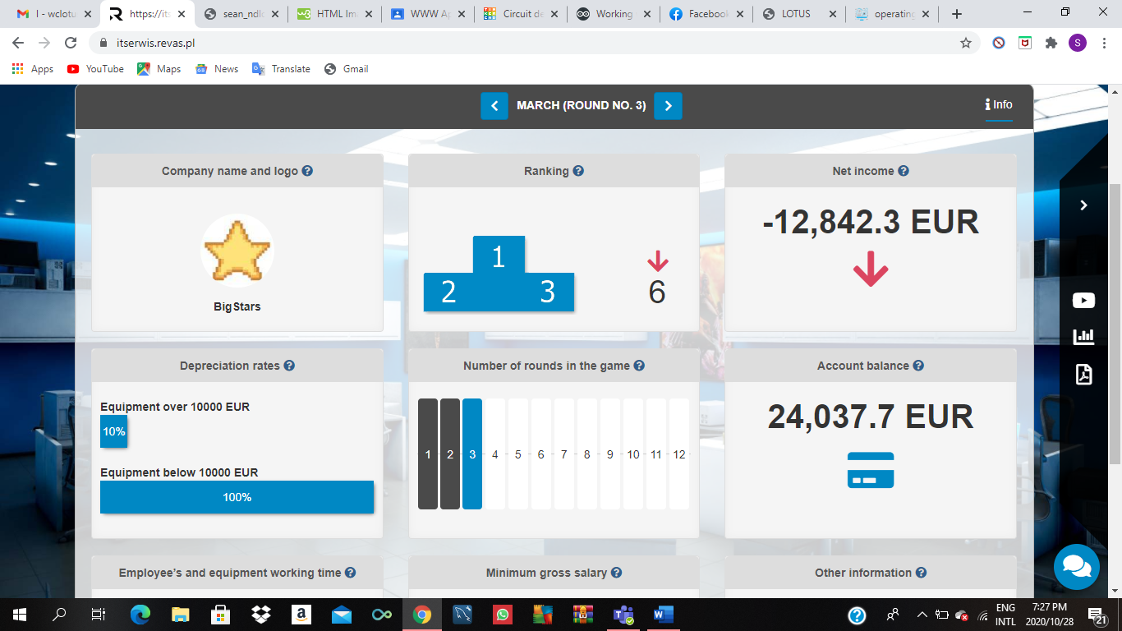

Round 1 net income

Round 3 net income

3. Round 3

Rankings were included this time and we came in 6th overall. In this round we added another service to our company. We decided on Network configuration and router installation as the new service offered by our company BigStars. We came to this conclusion because we could add it to our sales without having to employ another person. Our IT specialist would be able to handle it in addition to the workload he currently has.

**3.1** **Network configuration and router installation**

Network configuration is the process of setting a network's controls, flow and operation to support the network communication of an organization and/or network owner as defined by techopedia. It allows a system administrator to set up a network to meet communication objectives within a certain computer network. Every business has different requirements in relation to their network and the way they handle their voice, data & internet solutions, and so to complete this service for sale requires some amount of time unlike driver instalation. In the simulation it takes an average 1 hour to complete.

**3.2** **HR & Employment**

In my department the only ting I had to focus on this round was to keep my employee satisfied so that he is able to produce the best results he can. To do that in this round amenities are offered and so for my employees I decided to get a Radio, Microwave, and Fan for the employee. This results in higher employee satisfaction and lower risk of comlpaint. No new workstaions ,equipment or employees were hired. Although we were given the opportunity to add more services in this round we decided against it.

**3.3 Resources**

In this round we figured that since most of the resources we had bought in the preious round had not been used then we wont have to buy a lot in this one. And so the only resource we bought was a single router.

4.. Round 4

In the 4th round we were ranked 4th out of the 8 companies invovled in the simulation. We turned in a profit and were now only about 4 000 euros below our initial investment. We also introduced a new service but no new employees were hired. Most of the 4th round was similar to the 3rd except that in this round we were given the option to purchase amenities for the customers. The new service we decided to include this time was Removal of unwanted software due to it being in high demand at the time.

**4.1** **Removal of unwanted software**

This service is more about computer optimization than it is just simply removing software. The main focus is to optimize a computer by removing certain software that is hindering the increase in efficiency of the computer. This service does not need any resource all it needs is the equpment that our primary workshop is already working with. No new employee was hired for this as the current employee was still capable of handling the work. It also didn’t need a lot of time to complete, only half an hour is needed.

**4.2** **Investments and amenities**

In this current round no workstations and/or eqiuipment was purchased, the only change made was the decision to buy amenities for customers which were only introduced during this round. The amenity purchassed was current press to help increase customer satisfaction when they are waiting for their service. A fridge with beverages was purchased for the employees as an effort to help maintain the satisfaction and lower the risk of complaint.

**4.3** **Suppliers**

We switched suppliers again during this round and are currently using InterShop. We bought a lot more resources this current round which included, operating systems, power supplies,display matrix and routers.

5. ROUND 5

Our ranking has dropped to 7th, unfortunately in this round not a lot of decisions were made. No resources were bought and no services were offered up for sale. In the end all we had was expenses with no source of income.

NOTE: I concluded that this happened due to lack of communication which in other words meant that at this point in time we had still lacked teamwork and had poor communication skills. In order for us to get our company back on track someone amongst the group had to take over as the leader and restore or better yet increase communication amongst everyone.

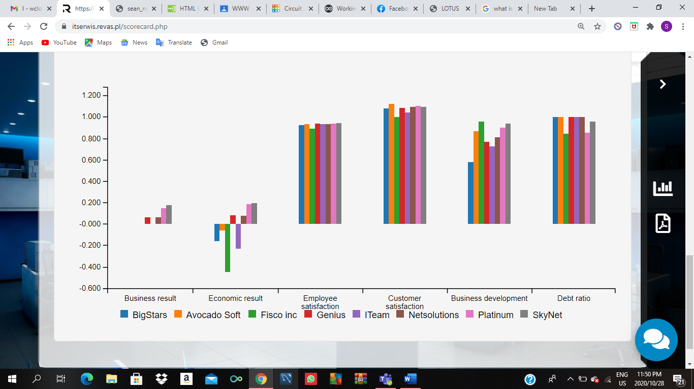

Skynet -has highest profit ratio

Bigstars-has no profit this round

The graph above is comparing our economic results, in other words whether or not our companies are turning a profit. I put this here to show the consequences of poor communication skills and low teamwork.

6. ROUND 6 & 7

Due to the decisions made in the past round in the previous round we ended up being the last company in the ratings and turned in no profit. Due to our desperate attempt to complete the 6th round we made very few decisions and didn’t add much more expenses than we currently had.

**6.1 Marketing**

We purchased 1 issue of leaflets as a form of traditional advertising, and also created a company website to help bring in more and new customers.

**6.2 Supplies and sales**

The person in charge of purchasing resources did not fulfil their duties and so none were purchased. The only service that was put up for sale was driver installation as it needed no resources to be sold.

**6.3** **Equipment**

No new equipment was purchased in the 6th it was only purchased on the 7th round. The equipment bought was a laptop, software for website preparation and a workshop lamp with magnifying glass.

7. Lessons and Observations so far

At this point in time our business was failing horribly, we were 22 000 dollars in debt and we had no direction. We weren’t even living up to our mission statement or moving anywhere towards our goal.

**7.1** **Observations**

* We lacked leadership and so lacked team work
* Very poor communication skills amongst us
* No business directive or goals
* When we each fulfil our roles that is when our business most efficient
* We lacked diversity in services we offer
* We need to be more analytical in our decision making
* Each of us need to put more effort into making more calculated and concise decisions
* Companies with more workstations supply more services and get more income:

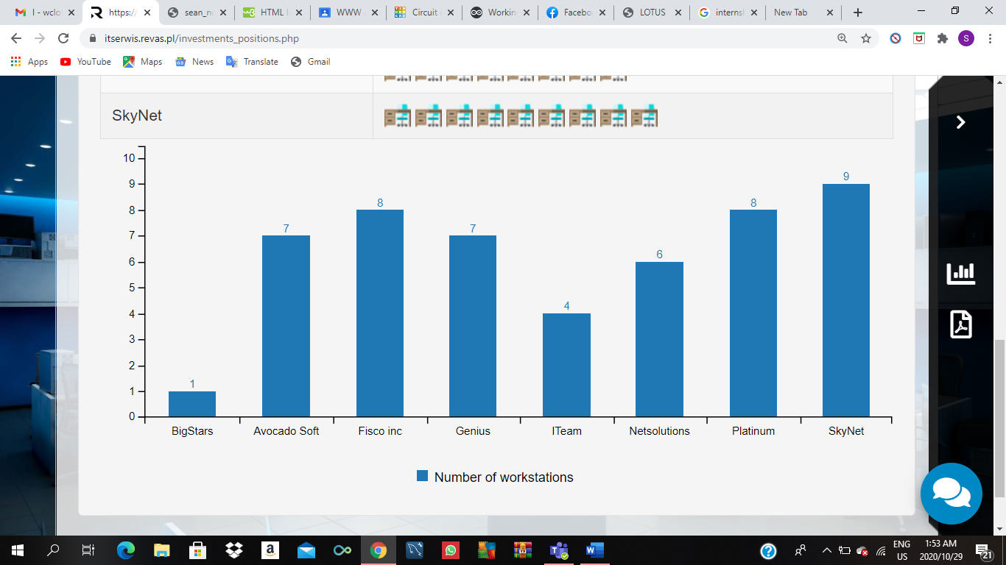

SkyNet, Netsolutions, and Fisco Inc are companies which had the top profits and from my observation this correlates with the fact that they all have high amount of work stations

**7.2** **Lessons learnt**

* I need to be better at sharing my thoughts and ideas when I’m working with my team.
* I need to react better to situations with enormous amounts of pressure, if I can do so then my decision-making skills would increase by a great margin.
* I learnt that in order for a team to function at full capacity each member must accept the role thrust onto them and make sure that they perform it to their best capabilities.
* We shouldn’t be afraid of purchasing a lot of supply because if the supply and demand go hand in hand then we can get more income.

8. ROUND 8

Due to us being in debt the first step we took was to get some funds in our account so we can purchase supplies, new equipment, workshops and employees. We took out a loan from the bank for 50 000 euros at an interest rate of 7% and is to be paid up within the next three months. We then offered up a new service called Recovering systematically corrupted data. It needs no resources and at the moment it’s one of the most demanded services. Although it requires some amount of time to complete with a new employee that obstacle is no longer an issue. It needs an IT specialist in order for the service to be sold and the equipment it needs is already in stock.

**8.1** **Data corruption and recovery**

Data corruption means refers to errors in computer data that occur during writing, reading, storage, transmission, or processing, which introduce unintended changes to the original data. When a program writes incorrect data, or when something interrupts a write process, the data can mess up and cause a corrupted file. Another way data can be corrupted is when your system is infected by a virus.

A hard drive contains a spinning disk called a "platter", where it stores all the 1s and 0s that make up your files. Sometimes, parts of the hard drive become unreachable due to an accidental software error, which is called a "soft bad sector." This prevents access to data within that sector. You can repair soft bad sectors by doing a disk scan, which untangles the problem causing the lock.

There is then a hard-bad sector, this is a situation at which the section of the drive has permanently become unreadable.

When our IT specialist is working on this service the goal is to recover as well as safeguard the data, he is tasked with getting. He must first diagnose and then assess each step carefully to make sure the data recovery as smooth as possible.

**8.2 Investments and HR**

We purchased more equipment for our workstation as well as some for the shared equipment. After some thorough discussions we decided it was about time we expanded and hired more people, and for that to be possible we need more workstations and so we purchased a workstation.

We added more amenities for both our customers and employees and this resulted in an increase in the satisfaction of both parties. For our customers we gave them free wifi and introduced a payment terminal. For our employees I gave them a gym membership. I then sent my IT specialist on training.

The happy face indicates high employee satisfaction 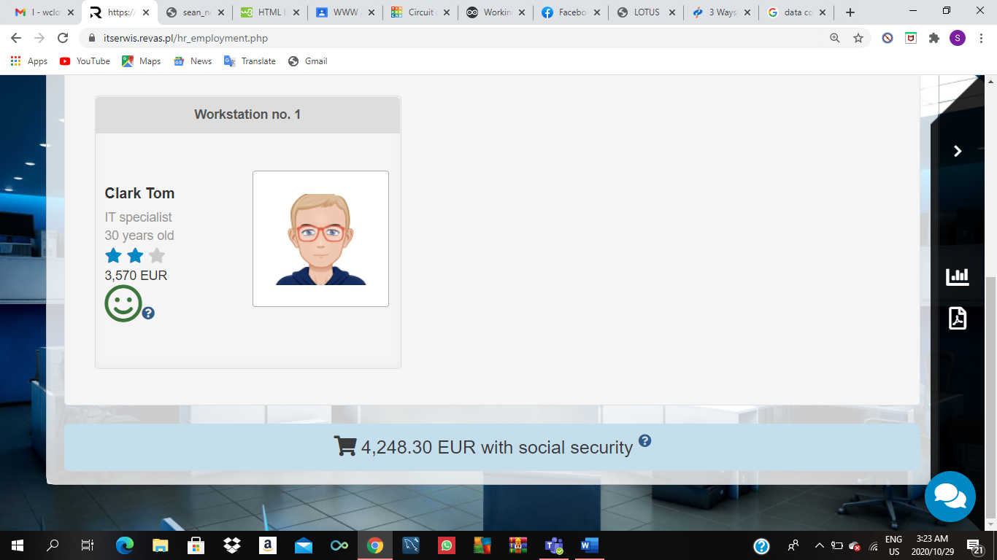

**8.3 Marketing**

In this round we included more on our online efforts to advertising, we put our company Information on an IT portal as well as made a mobile application for our company making it easier to access information on our company as well as reserve appointments for services required.

**8.4** **Supplies and sales**

We bought a fair amount of resources because most of the services we offer mostly require the skill of our employees as well as competent equipment in order to be sold. The services we offered up for sale in this round were Driver installation, Recovering systemically corrupted data, and Operating system installation.

9. ROUND 9

Although we were still last on the round ranking and didn’t turn a lot of profit, we were able to survive our debt and are still steadily getting back to normal. We brought about an overall increase in the amount of services we offer and decided to include Creating a website with cms, laptop cleaning, laptop power supply and repair, and power supply socket replacement. The rest of the round was similar to the 8th just with more resource purchased.

**9.1 Creating a website with cms**

Building a website isn’t easy. There are many websites with good content, but the design is poor, and this is due to the programmer in charge of the project being unable to follow the necessary steps used to make websites. Web development isn’t only about implementing the codes on a website; web design also plays an essential role in the development process.

The web development process has about 8 steps which include:

1. **Information Gathering**- this is the most important step in the web development process as this is where the customer’s requirements are properly defined and discussed by the programmer and the customer. The information gathered here makes up the sitemap.
2. **Planning**- after my programmer has gathered sufficient information about the business, it’s time for the creation of sitemaps and wireframe. The primary motive of a site map is to create a website user-friendly and create a structure of a site. A wireframe provides a visual description of a site.

Other than that, this is the stage where the programmer decides what functions and features will be on the site.

1. **Design-** web design is a key part of the creation of a website. The web design is created according to the target audience. Due to the fact that each website is different and unique the programmer has to keep in mind a set of basics that help with web design which are a theme, colour contract, where to place text, images, videos, etc.
2. **Development-** In this stage, the design of the website the programmer has started to run the codes on it. A web developer will use codes on the site to make it function and run smoothly. As per sitemaps, a home page is first designed than the other pages. Here the programmer can finally start making the website.
3. **Content writing-** After the development process, now it’s time to write the content on your website. Content writing is where you need to write and publish content all the time so as to fulfil business objectives. Here the job is more so for the marketing department but it does include the programmer. At this point the most crucial task is to be as engaging and as communicative as you possibly can with the customer.
4. **Testing-** this is a routine part of the web development process, just like it is in the software development process. Every pages and links are tested before launching the site to make sure nothing is broken. Every form and script are checked, and the programmer will also run spelling check software so as to find possible typing errors. Code validators will be used to make sure the code follows the current web development standards. In this stage, your site is tested for several things including Website speed, Cross-browser compatibility, and Multiple screen tests.
5. **Maintenance-** To avoid further inconvenience, most developers are happy to provide maintenance services. Unfortunately, our business does not provide maintenance services it only makes the site.
6. **Choosing CMS-** Every website needs a good content management system (CMS). The most commonly used cms is WordPress as it is easy to maintain and less expensive. 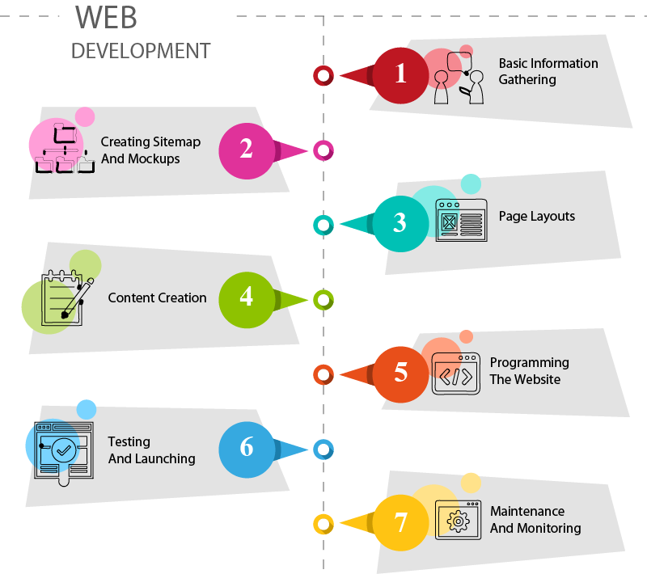

**9.2 Investments and employment**

We purchased 2 more workshops in this stage as well as new equipment for the workshop we acquired in round 8. As the head of the HR department I made a decision to employ a programmer this time. I hired an experienced senior programmer named Harris and sent both him and my IT specialist to training. No new amenities were purchased for neither the customers nor the employees.

**9.3 Supplies and sales**

This time we learnt from our past mistakes and purchased an ample amount of resources which include 25 routers, operating systems and 15 graphics for the website. Creating a website with cms, Driver installation, recovering systemically corrupted data, and Operating system installation are the services we decided to offer up for sale in this round.

10. ROUND 10 & 11

In this round a lot of the decisions made in the previous round were repeated. Our efforts in increasing profits had worked and we were no longer in debt. We ranked 7th which was an improvement. Each of us were individually contributing to the common goal as a team.

**10.1 HR & employment**

I hired another 2 employees as I had lost one due to my lack of negligence towards the satisfaction of my employees. I hired a programmer as well as an IT specialist and sent them both on training to help increase the quality of the services they produce.

To correct my previous mistakes and errors I decided to give the employees who have been working for the company for a while a bonus. I also purchased some more amenities for the workplace, new amenities include; coffee machine, and medical care.

In terms of sales no new services were offered up for sale only all the offers of the business. We also increased the amount of resources we purchased because it worked out impressively in the previous round then it should bring similar results to this one.

**10.2 Investments**

Although no investments were made in round 10, we decided to purchase 4 new workshops to be used in round 12. Workshops 2 – 4 were upgraded with brand new equipment in order for the employee to be able to provide the services offered up by the company.

CONCLUSION

My goals at the onset of this internship were to improve my communication skills whilst learning about IT services as well as how software development, web development, graphic material creation, computer networking is all managed within an IT company.

During the game I found out that my teamwork skills were not as good as I had first thought them to be. The good part is that I noticed my strengths and weaknesses and by the 8th round and started focusing on working on those weaknesses.

After a detailed meeting during the completion of the 8th round our teamwork as well as our communication was improved as can be seen by the graph below:

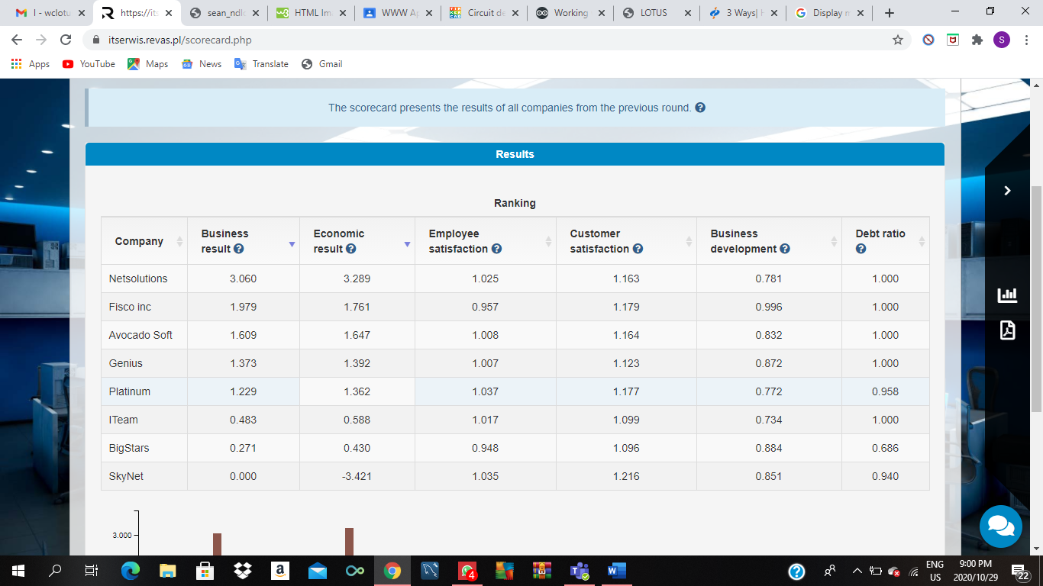

Our business results and our economic results are positive meaning the changes we made after our meeting helped us make profitable decisions.

11. ROUND 12

Some decisions made in the previous round were corrected in this one. We bought more resources than demanded by the market and so didn’t turn a profit as high as the last month.

**11.1 HR**

My final decisions for this round were to hire more employees and make it a total of 3 programmers and 3 IT specialists. Bonuses were handed out to the employees who had been with the company for a while, and new employees were sent to training. No new amenities were purchased and so this is how the game was concluded.

12. ACCOMPLISHMENTS

* Better communication skills
* Better in working in teams
* Become more analytical and calculative in my decision making
* Gained knowledge on the basics of running an IT company
* Gained knowledge on the various services sold by IT companies and how the process of development works with them